INTRODUCTION TO CYBERSECURITY

OPERATING SYSTEM INSTALLATION
TASK1: Download the latest Ubuntu Desktop ISO image and create a bootable USB drive using Rufus or Balena Etcher.
- Open a web browser on the computer.
- Go to the official Ubuntu website.
- Download the latest Ubuntu Desktop ISO file.
- Download and install Rufus.
- Insert a USB drive into the computer.
- Open Rufus.
- Under Device, select the USB drive.
- Under Boot selection, select the downloaded Ubuntu ISO file.
- Keep the recommended settings.
- Click Start.
- If Rufus asks for confirmation, select the recommended option.
- Wait until the process is completed.
- Safely eject the USB drive.
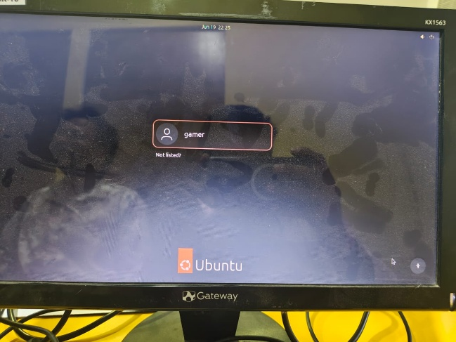
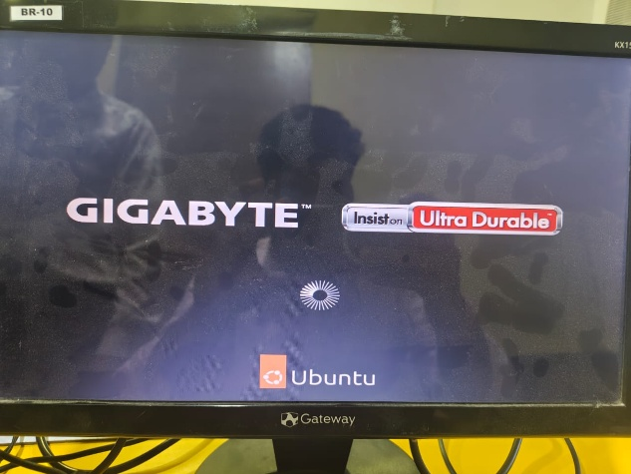

TASK2: Install Ubuntu Desktop on a virtual machine using VirtualBox or VMware Player, and take a screenshot of the desktop after successful installation.

- Download and install Oracle VirtualBox.
- Open VirtualBox.
- Click New.
- Enter the name: Ubuntu Desktop
- Select the downloaded Ubuntu ISO file when asked.
- Give the virtual machine suitable resources, for example:
• RAM: 4 GB
• CPU: 2 cores
• Storage: 25 GB or more
- Click Finish/Create.
- Start the virtual machine.
- The Ubuntu installer will open.
- Select Install Ubuntu.
- Choose the required keyboard layout.
- Continue through the installation options.
- Create the user account as described in Question 3.
- Select the required installation option.
- Wait for Ubuntu to finish installing.
- Restart the virtual machine when requested.
- Log in to Ubuntu after restarting.

TASK3: During installation, set up a user account named 'cyberstudent' with a strong password (at least 8 characters, mix of letters, numbers, and symbols).
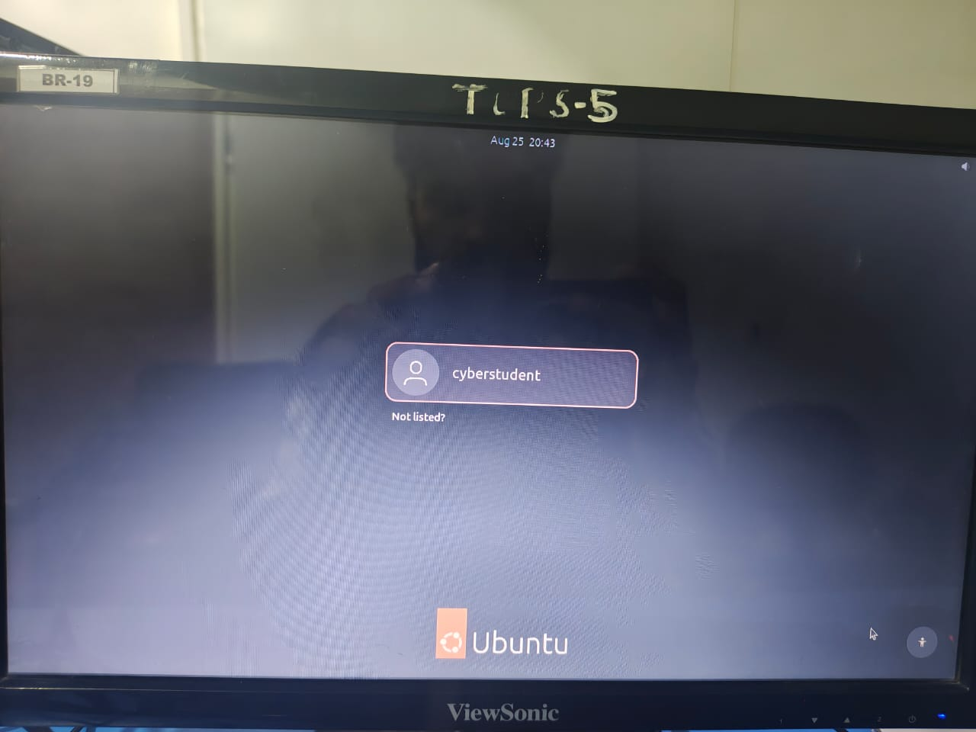

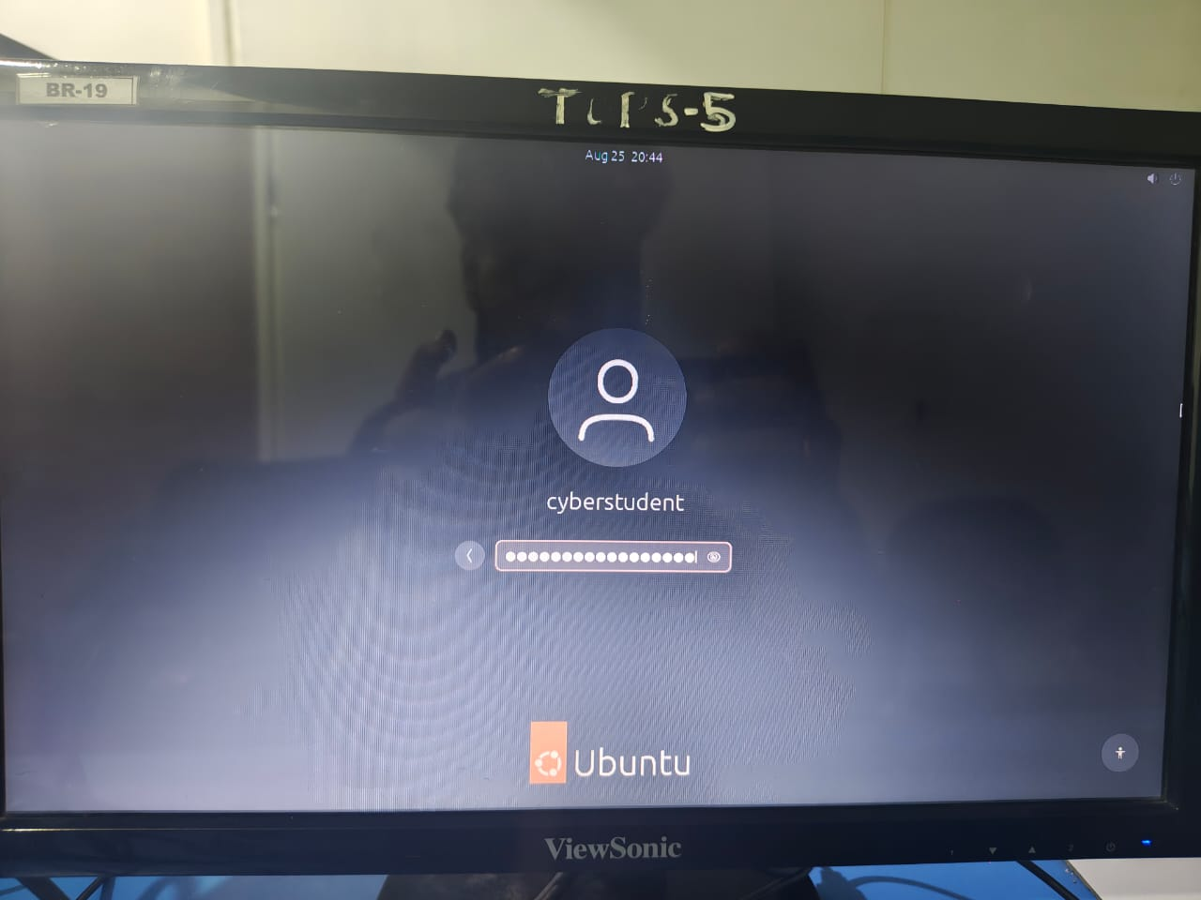

TASK4: After installing Ubuntu, open the terminal and run the command 'uname -a' to display OS details. Save the output to a text file named os-info.txt.
- Log in to Ubuntu.
- Open Terminal.
- Type: uname -a
- Press Enter.
- Ubuntu will display information about the operating system and kernel.
- To save the output directly into a text file, type:
- Press Enter.
- Check that the file was created by typing: uname -a > os-info.txt
- Press Enter.
- Check that the file was created by typing: ls
- You should see : os-info.txt
- To view saved information, type: cat os-info.txt

